FODS ASSIGNMENT 7

Name – Atharva Shivaji Dabkekar
Roll no. – 2090138
PRN - 1251090357
Division – S.Y A
Batch – 2
DATE – 25-08-2026 TIME – 8:00 TO 10:00
Practical 7: Non-Comparison-Based Sorting
Implement Counting Sort, Radix Sort, and Bucket Sort. Compare their efficiency with comparison-based sorting algorithms.
Answer:
- Counting Sort:
Code:
#include <iostream>
using namespace std;
void countingSort(int arr[], int n) {
if (n <= 0) return;
int max_val = arr[0];
for (int i = 1; i < n; i++) {
if (arr[i] > max_val) max_val = arr[i];
}
int* count = new int[max_val + 1]();
int* output = new int[n];
for (int i = 0; i < n; i++) {
count[arr[i]]++;
}
for (int i = 1; i <= max_val; i++) {
count[i] += count[i - 1];
}
for (int i = n - 1; i >= 0; i--) {
output[count[arr[i]] - 1] = arr[i];
count[arr[i]]--;
}
for (int i = 0; i < n; i++) {
arr[i] = output[i];
}
}

int main() {
int n;
cout << "Enter the number of elements: ";
cin >> n;
if (n <= 0) {
cout << "Array size must be greater than 0." << endl;
return 1;
}
int* arr = new int[n];
cout << "Enter " << n << " non-negative integers separated by spaces:\n";
for (int i = 0; i < n; i++) {
cin >> arr[i];
}
cout << "\nOriginal array: ";
for (int i = 0; i < n; i++) {
cout << arr[i] << " ";
}
cout << "\n";
countingSort(arr, n);
cout << "Sorted array: ";
for (int i = 0; i < n; i++) {
cout << arr[i] << " ";
}
cout << "\n";
return 0;
}
Output:
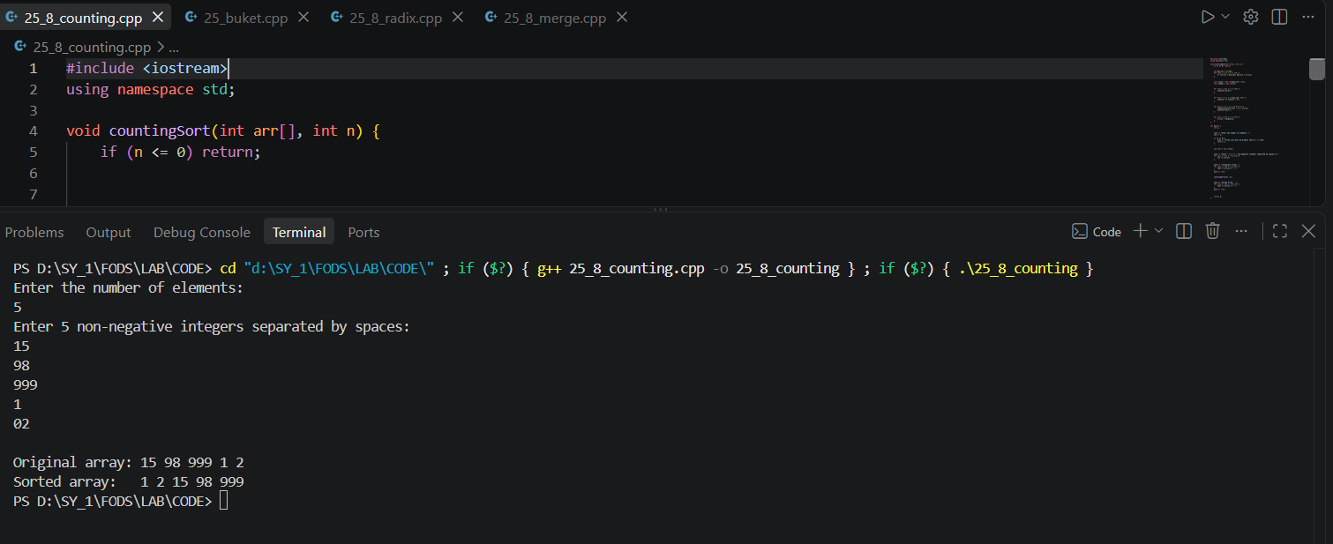

- Radix Sort :
Code :
#include <iostream>
using namespace std;
void countingSortForRadix(int arr[], int n, int exp) {
int* output = new int[n];
int count[10] = {0};
for (int i = 0; i < n; i++) {
int index = (arr[i] / exp) % 10;
count[index]++;
}
for (int i = 1; i < 10; i++) {
count[i] += count[i - 1];
}
for (int i = n - 1; i >= 0; i--) {
int index = (arr[i] / exp) % 10;
output[count[index] - 1] = arr[i];
count[index]--;
}
for (int i = 0; i < n; i++) {
arr[i] = output[i];
}
}
void radixSort(int arr[], int n) {
if (n <= 0) return;
int max_val = arr[0];
for (int i = 1; i < n; i++) {
if (arr[i] > max_val) max_val = arr[i];
}
for (int exp = 1; max_val / exp > 0; exp *= 10) {
countingSortForRadix(arr, n, exp);
}
}
int main() {
int n;
cout << "Enter the number of elements: ";
cin >> n;
if (n <= 0) {
cout << "Array size must be greater than 0." << endl;
return 1;
}
int* arr = new int[n];
cout << "Enter " << n << " non-negative integers separated by spaces:\n";
for (int i = 0; i < n; i++) {
cin >> arr[i];
}
cout << "\nOriginal array: ";
for (int i = 0; i < n; i++) {
cout << arr[i] << " ";
}
cout << "\n";
radixSort(arr, n);
cout << "Sorted array: ";
for (int i = 0; i < n; i++) {
cout << arr[i] << " ";
}
cout << "\n";
return 0;
}
Output :
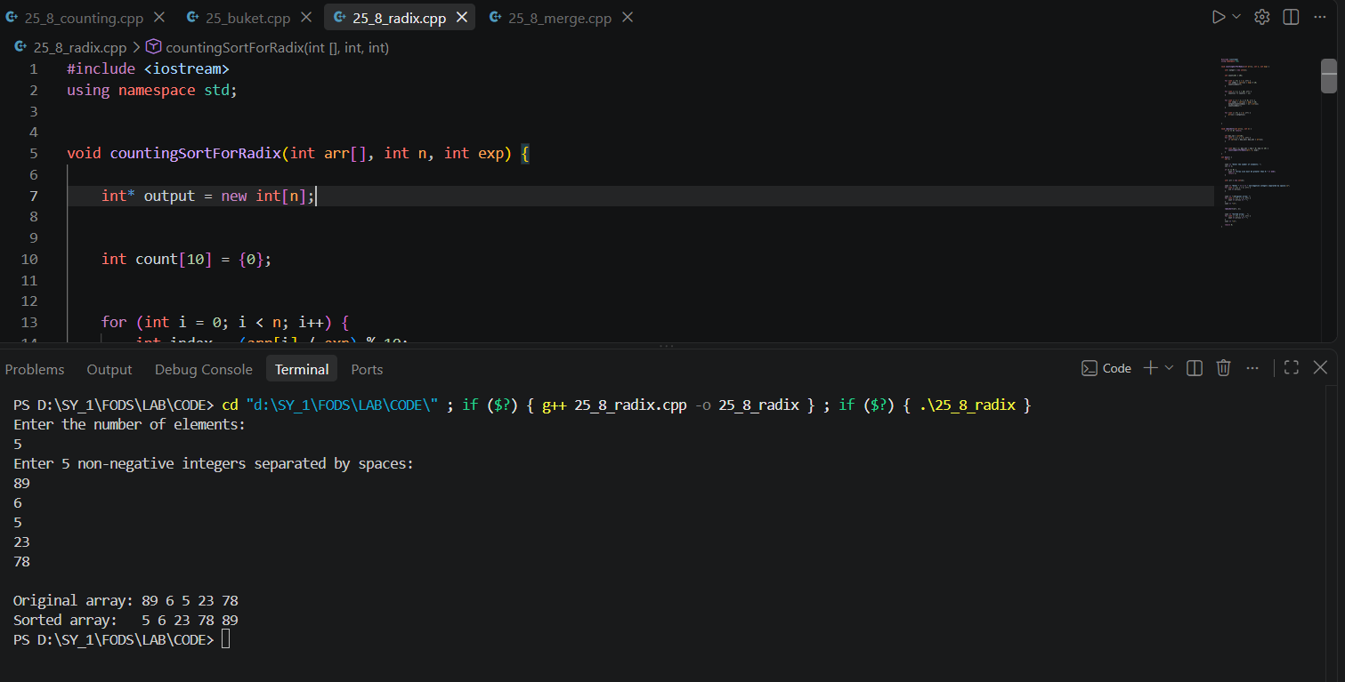

- Buket Sort :
Code:
#include <iostream>
using namespace std;

int main()
{
int a[100];
int bucket[10][100];
int count[10] = {0};
int n;

cout << "Enter number of elements: ";
cin >> n;

cout << "Enter elements (0-99): ";
for(int i = 0; i < n; i++)
{
cin >> a[i];
}

// Put elements into buckets
for(int i = 0; i < n; i++)
{
int index = a[i] / 10;
bucket[index][count[index]] = a[i];
count[index]++;
}

// Sort each bucket
for(int i = 0; i < 10; i++)
{
for(int j = 0; j < count[i] - 1; j++)
{
for(int k = 0; k < count[i] - j - 1; k++)
{
if(bucket[i][k] > bucket[i][k + 1])
{
int temp = bucket[i][k];
bucket[i][k] = bucket[i][k + 1];
bucket[i][k + 1] = temp;
}
}
}
}

// Combine buckets
int index = 0;

for(int i = 0; i < 10; i++)
{
for(int j = 0; j < count[i]; j++)
{
a[index] = bucket[i][j];
index++;
}
}

cout << "Sorted Array: ";

for(int i = 0; i < n; i++)
{
cout << a[i] << " ";
}

return 0;
}
Output :
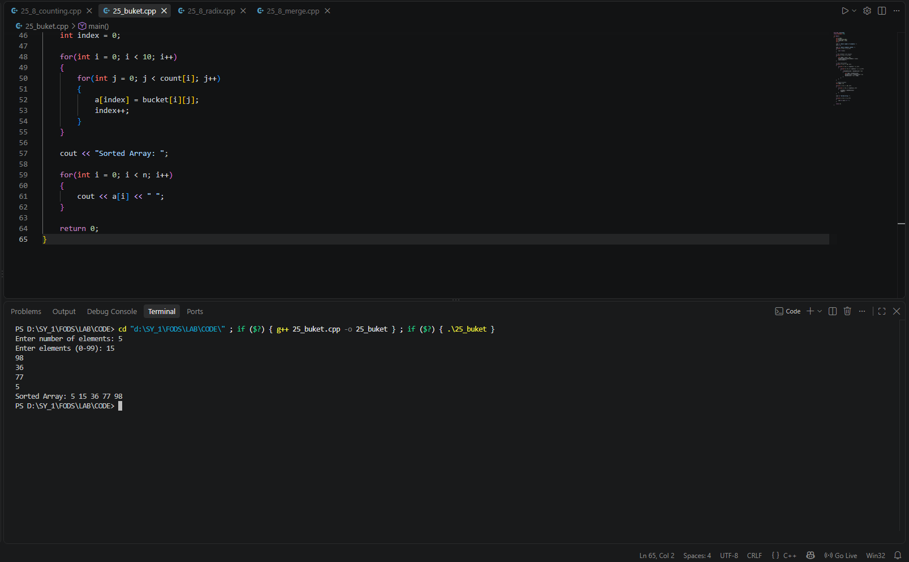
- Merge Sort :
Code :
#include <iostream>
using namespace std;

void merge(int a[], int low, int mid, int high)
{
int temp[100];

int i = low;
int j = mid + 1;
int k = 0;

while(i <= mid && j <= high)
{
if(a[i] < a[j])
{
temp[k] = a[i];
i++;
}
else
{
temp[k] = a[j];
j++;
}
k++;
}

while(i <= mid)
{
temp[k] = a[i];
i++;
k++;
}

while(j <= high)
{
temp[k] = a[j];
j++;
k++;
}

for(i = low, k = 0; i <= high; i++, k++)
{
a[i] = temp[k];
}
}

void mergeSort(int a[], int low, int high)
{
if(low < high)
{
int mid = (low + high) / 2;

mergeSort(a, low, mid);
mergeSort(a, mid + 1, high);

merge(a, low, mid, high);
}
}

int main()
{
int a[100];
int n;

cout << "Enter number of elements: ";
cin >> n;

cout << "Enter elements: ";
for(int i = 0; i < n; i++)
{
cin >> a[i];
}

mergeSort(a, 0, n - 1);

cout << "Sorted Array: ";

for(int i = 0; i < n; i++)
{
cout << a[i] << " ";
}

return 0;
}
Output :
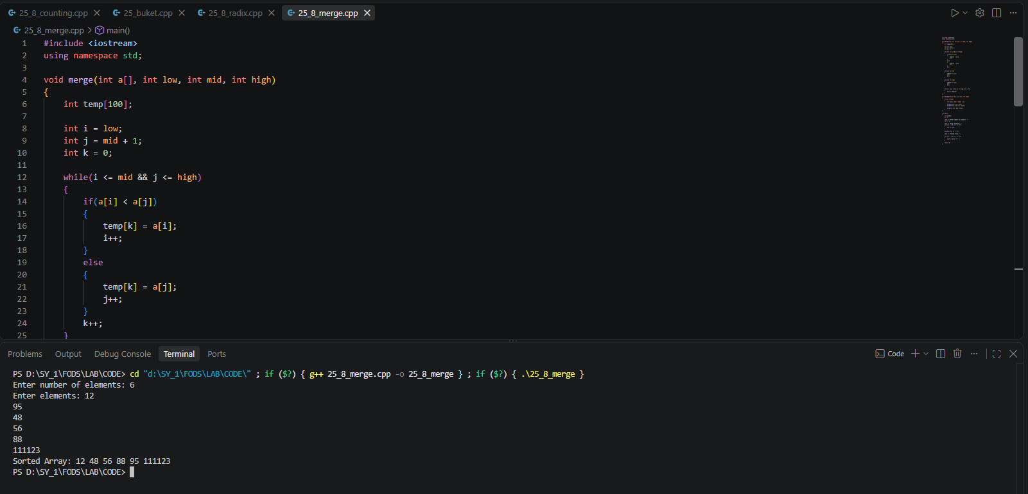
- Comparison With Comparison Based Sorting Algorithm:
Feature | Counting Sort | Radix Sort | Bucket Sort | Merge Sort | Quick Sort
Type | Non-Comparison | Non-Comparison | Non-Comparison | Comparison | Comparison
Best Case | O(n + k) | O(d(n + k)) | O(n + k) | O(n log n) | O(n log n)
Average Case | O(n + k) | O(d(n + k)) | O(n + k) | O(n log n) | O(n log n)
Worst Case | O(n + k) | O(d(n + k)) | O(n²) | O(n log n) | O(n²)
Space Complexity | O(n + k) | O(n + k) | O(n + k) | O(n) | O(log n)
Stable | Yes | Yes | Yes* | Yes | No
Best Used For | Small range of integers | Large numbers | Uniformly distributed data | General-purpose sorting | Fast in-memory sorting

